Brandon Castro

816549663

12/10/2013

Student Project

//Objective

---------------

STORE COMBINATION: When the user pushes the button in a certain combination, the program will read the input and store the combination. Given a time interval, the program allows a window of time for button inputs. The combination to be read will be a 3 digit code. An LED will light up every time the button is pressed to show that a value has been correctly read.

//Code

---------------

#include <stdio.h>

#include <wiringPi.h>

// LED Pin - wiringPi pin 0 is BCM_GPIO 17.

// Switch Pin - wiringPi pin 1 is BCM_GPIO 18.

// Some code implemented from WiringPi examples (such as defining LED/SWITCH, etc)

/* I attempted to use the waitForInterrupt methods (both ISR and the old method)to read consecutive switch entries

but was unsuccessful. There is some leftover commented code on the bottom */

// The code works as intended, although if you leave the button pressed for a little too long, bouncing occurs, but rarely

#define LED 0

#define SWITCH 1

#define COUNT_KEY 0

void storeNum(int x)

{

if(!digitalRead(SWITCH))

{

digitalWrite(LED, HIGH);

delay(250);

digitalWrite(LED, LOW);

x++;

}

delay(250);

}

int main(void)

{

printf ("STORE COMBINATION\n") ;

printf ("--------------------\n");

wiringPiSetup () ;

pinMode (LED, OUTPUT) ;

pinMode (SWITCH, INPUT);

digitalWrite(SWITCH, HIGH);

digitalWrite(LED, LOW);

int i = 0;

int counter = 0;

int combo[] = {0, 0, 0};

for(i=0; i<3; i++)

{

printf("Password digit #%d?\n", i+1);

delay(500);

int j = 0;

for(j=0; j<10; j++)

storeNum(counter);

printf("Number of presses read: %d\n", counter);

combo[i] = counter;

delay(1500);

}

printf ("--------------------\n");

printf("Combo is %d - %d - %d\n", combo[0], combo[1], combo[2]);

return 0;

/* for(i=0; i<3; i++)

{

printf("Input %d\n", i);

delay(1000);

printf("Waiting... "); fflush(stdout);

while(counter == lastCounter)

{

piLock(COUNT_KEY);

counter = globalCounter;

piUnlock(COUNT_KEY);

delay(500);

}

printf("Counter is %d\n", counter);

pass[i] = counter;

lastCounter = counter;

delay(2000);

}*/

}

//RPi Setup

---------------

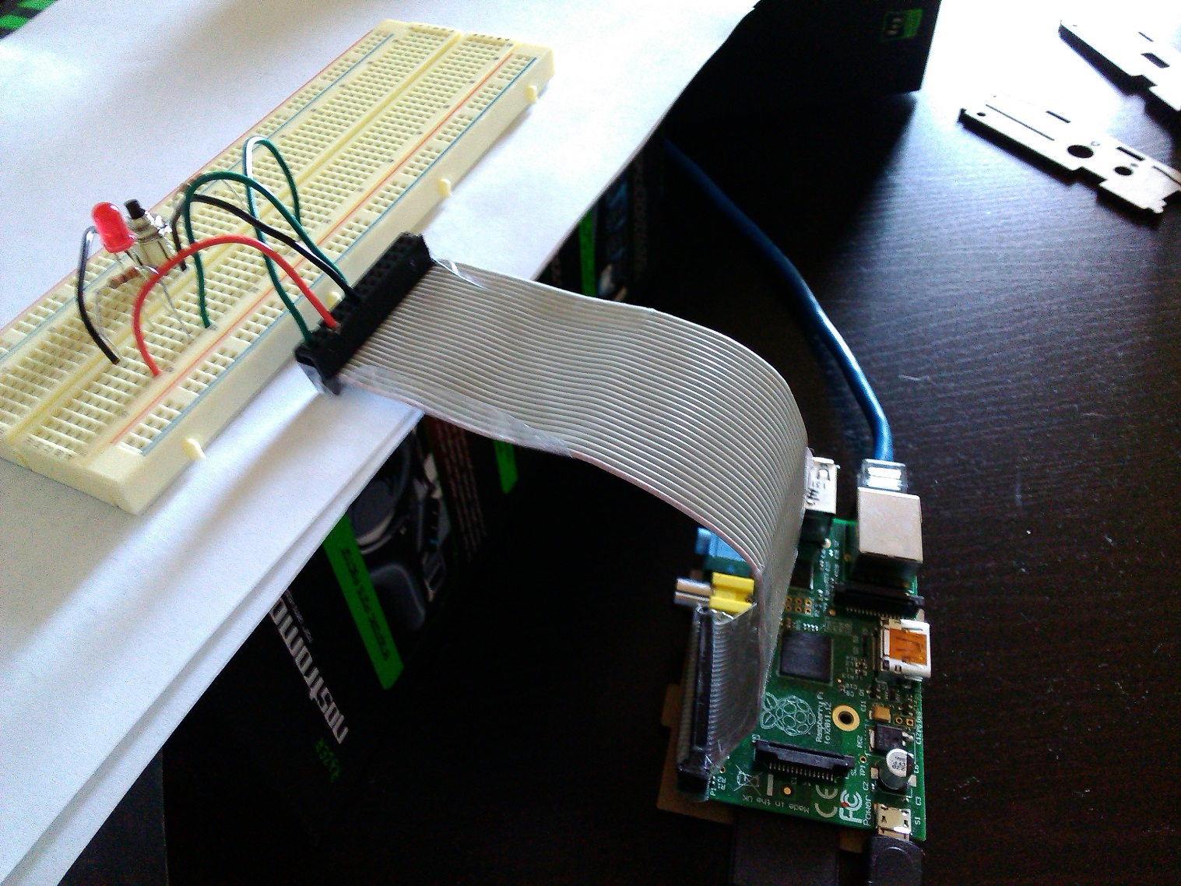

// Printout

---------------

